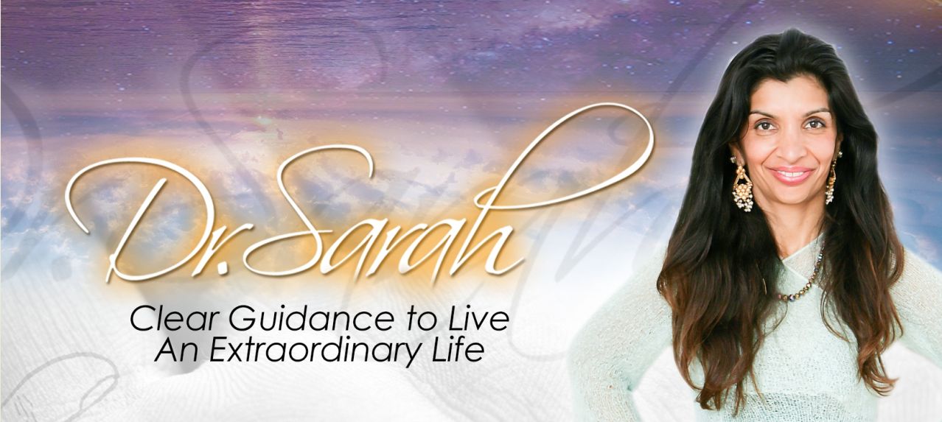

Application for Dr. Sarah’s 2020 Small Group Coaching Program
(Download the questionnaire and answer the questions on this document, then send as an attachment to support@drsarahlarsen.com. Or copy and paste the questions into the body of an e-mail and then write your answers. Once finished, send answers to support@drsarahlarsen.com)
Name: _______________________________
Date: ________________________________
Email: _______________________________
Phone #: _____________________________
I want to know and serve you better in the future so thank you for filling this out completely!
1. Why do you feel called to transform your life in 2020 with Dr. Sarah and the group coaching program?
2. What is it that you are seeking most in your life? What Miracle do you want to bring about in your life?

3. How committed are you to making that Miracle happen?

4. Are you willing to invest time, energy, and money so you can create the life you deserve?

5. What blocks do you want to clear to make 2020 extraordinary?

6. How open are you to getting out of your comfort zone? Are you open to experiencing miracles?

7. Can you participate fully in the Zoom meetings and assignments and bring your beginners mind to this journey of awakening?

8. Can you unplug from the mainstream limited way of thinking and indulge in the deeper transformation available from your soul?

9. Is there anything else you would like for us to know?

10. Can we email you with upcoming free events, special discounts, and community offerings?____________

When you finish the application questions please send your answers via e-mail to support@drsarahlarsen.com. Please let me know if you have any questions!

Thank you and have a great day!

Dr. Sarah Larsen
424-757-4197 or
support@drsarahlarsen.com

